Roadmap "new rail infrastructure/services 2030" – D.T3.2.3 - D.T3.2.7
TEMPLATE

Work paper | Version 1.0  2.2021

- Introduction
This document represents the general methodology for the draft of the roadmap, suggested by ITL Foundation as WP.T3 Leader. As stated in the Application Form, roadmap is an operation plan that describe how to realise the interventions included in the priority list (D.T1.4.2) and to implement the potential policy measures (D.T1.4.3) that have been identified in the studies of WP.T1. The time horizon for the implementation of the actions is 2030. Please use this template both for the draft roadmap (D.T3.2.3) and the final roadmap (D.T3.2.4). The actions included in the final roadmap may vary from those one illustrated in the draft roadmap due to the recommendations of the advisory board about funding possibilities and policy measure.
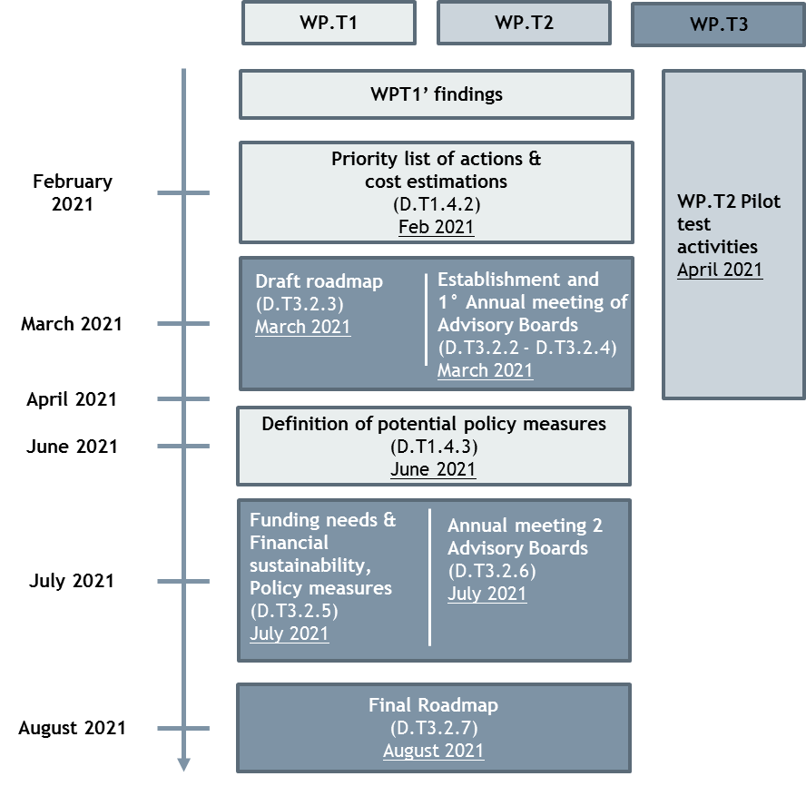
Each partner has requested to elaborate the roadmap in its respective region (seven at project level: Thuringia, Slovenia, Emilia Romagna, Friuli Venezia Giulia, Croatia, Styria, Westpomerania) following these steps:
- the draft version of the roadmap (D.T3.2.3) is going to be discussed during the first Annual Meeting of Advisory Board (D.T3.2.4), that should be organised by March 2021.
- the final Roadmap (D.T3.2.7) will be finalized in the light of the advisory boards' recommendations on funding possibilities and policy measures (D.T3.2.5), discussed during the second Annual Meeting of Advisory Board (D.T3.2.6).
The roadmap should be structure following this recommendation: first chapters concern the introduction of road map’s aims and content (chapter 1), the lessons learned from WP.T1’s studies and researches and WP.T2’s pilot activities (chapter 2) and the main challenges in order to launch new infrastructures and services (chapter 3). In the chapter 4, partners have to list the interventions of the road map, identifying for each of them the priority area, the time horizon and the expected cost. Then, a description of those actions considered as a priority has to be provided (chapter 5).
- Structure for Roadmap development
- Introduction
In this section, please briefly the content of the roadmap and the aims to achieve by the implementation of actions described.

- Lessons learned from WP.T1 and WP.T2
In this section, please describe the main findings from the studies and researches carried out in the WP.T1 and their contribution to the elaboration of the roadmap. In this section you may include also the intermediate and final findings from pilot activities (WP.T2)

- Main challenges for the implementation of roadmap
In this section, please describe what are the main challenges related to the implementation of actions included in the roadmap and the strategy that will be put in place in order to overcome them.

- Identification of the actions
In this section the roadmap’s actions are going to be identified. Please fill the table below, gathering the actions by priority areas. For the identification of priority areas, please refer to the deliverable D.1.4.2.- Priority list of actions & cost estimations (i.e. transport infrastructure, rolling stock / machinery, Services /operations, Legislation/ administration or any other macro-area identified within the project) and the deliverable D.T1.4.3 - Definition of potential policy measures

ACTION/MEASURE | ESTIMATED COSTS | TIME HORIZON
- TRANSPORT INFRASTRUCTURE
A.1 Upgrading of the left shunting track of Ravenna Port | 21.000.000 € | 2025
A.2 Realisation of new railway line | 150.000.000 € | 2030
A.3 … | … | …
- ROLLING STOCK / MACHINERY
B.1 Rolling stock replacement | 180.000.000 € | 2028
B.2 | … | …
… | … | …
- LEGISLATION/ADMINISTRATION
C.1 … | … | …
… | … | …
D.1 … | … | …
…

- Detail description of priority actions/measures
In this section, please describe the actions considered as a priority from those one listed in the above table. At least, one intervention for each priority areas has to be described.

Number and name of intervention: A.1 Upgrading of the left shunting track of Ravenna Port
Priority area  Indicate the priority area of the intervention | Transport infrastructure
Description of action/measure  Describe the action foreseen and the expected results from its implementation | ..
Description of the main steps for its implementation  List and describe in detail the main steps for the implementation of the action (i.e. planning phase, tender procedures, etc…) | ..
Stakeholders involved  List the stakeholders involved. What is their role in the action? Will they be the direct beneficiaries? | ..
Timeline  Indicate the time horizon for the implementation of the action | ..
Investment cost  How much will cost the construction/realization of the future initiative/action/technology? | ..
Sources of financing  What are the sources of financing? Private capital, public capital, CEF, etc...  How much is the share covered by each of them? | ..
Impact of the initiative  Describe the expected future economic, social, environmental impacts of this initiative | ..
Compliance with the overall objectives of REIF project  Describe the expected contribution of the action/measure to the achievement of REIF project (e.g. connection to TEN-T corridor, ...) | ..
Compliance with guidelines of national and regional planning instruments  Describe the compliance with the aim of national and regional planning instruments | ..

Number and name of intervention: B.1 Rolling stock replacement
Priority area  Indicate the priority area of the intervention | Transport infrastructure
Description of action/measure  Describe the action foreseen and the expected results from its implementation | ..
Description of the main steps for its implementation  List and describe in detail the main steps for the implementation of the action (i.e. planning phase, tender procedures, etc…) | ..
Stakeholders involved  List the stakeholders involved. What is their role in the action? Will they be the direct beneficiaries? | ..
Timeline  Indicate the time horizon for the implementation of the action | ..
Investment cost  How much will cost the construction/realization of the future initiative/action/technology? | ..
Sources of financing  What are the sources of financing? Private capital, public capital, CEF, etc...  How much is the share covered by each of them? | ..
Impact of the initiative  Describe the expected future economic, social, environmental impacts of this initiative | ..
Compliance with the overall objectives of REIF project  Describe the expected contribution of the action/measure to the achievement of REIF project (e.g. connection to TEN-T corridor, ...) | ..
Compliance with guidelines of national and regional planning instruments  Describe the compliance with the aim of national and regional planning instruments | ..

- Conclusion

In this final section please sum up the vision and content of the roadmap and illustrate the expected results and impacts from its implementation. Please list the key words or key concepts that represents the roadmap’s vision.

This information, if already available, could be assumed in the draft version and it has to be confirmed in the final one
This information, if already available, could be assumed in the draft version and it has to be confirmed in the final one

